User guide

Point at the floor with the controller and press trigger to teleport, white ray means you can teleport there, red ray means you cannot.

To grab a ball put hand next to the ball, then press and hold on the grab button on the controller to pick it up.

This is an education game for age ranges of 8-12 and it is a simple game for children to learn how to use VR.

Hierarchy –

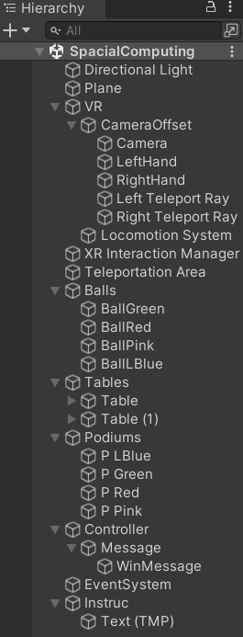

BallInteract Script –

This script is the controller, this script holds all the balls, tables and colours and allows the balls to be placed on the tables which then checks to see if the correct coloured balls are on the correct coloured table.

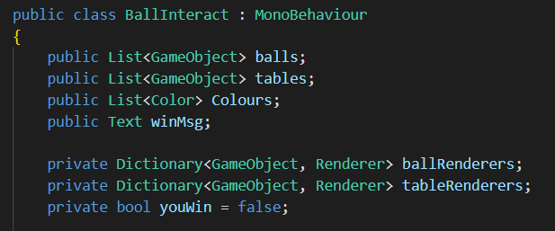

The first two are arrays for the balls and tables. The colour list is an array to store the colours of the balls and tables.

winMsg is a reference for the text component for when the player wins.

Ball and table renderers are dictionaries which maps each table and ball to the corresponding colour.

youWin is a Boolean variable which turns to true when player wins the game.

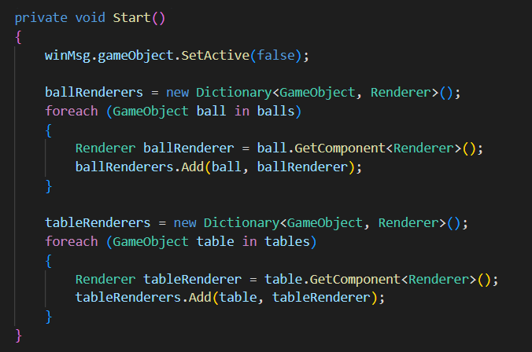

This is a method which only gets called at the start of the game.

winMsg makes sure that the text is disabled when opening the game.

Ballrenders makes an empty dictionary.

The foreach loop goes through each ball in the ball list.

Renderer ballrenderer, this retrieves the renderer component from each ball in the scene.

TableRenderers is the same but for the tables.

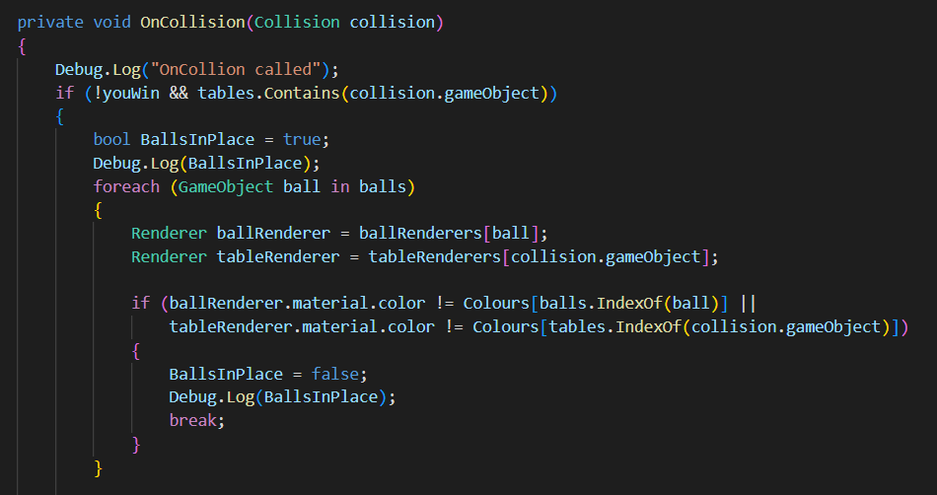

This is the collision method; this is called when a collision occurs between the ball and the tables.

The if statement checks if the game has not been won and if the collision object is one the tables in the list, when both conditions are met the rest of the code is run.

Bool BallsInPlace is a Boolean value which becomes true when the condition is met.

The foreach loop goes through each ball in the ball list.

Ball renderer retrieves the rendered component in the balls dictionary and the table renderer does the same but for the tables.

Then next if statement check if the colour of the balls is different from the correct colour OR if the colour of the tables is different from the correct colour, if either condition is true then the ball is not in the correct place and sets BallsInPlace to false.

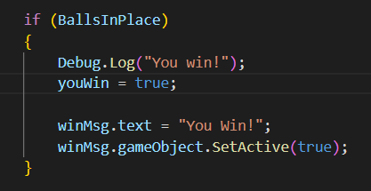

This code just checks if BallsInPlace is true then it sets youWin to true, sets the text to “You Win” and then activates the canvas to display the message.